# **SEQUENCE DIAGRAM**

1. ONLINE COURSE RESERRVATION

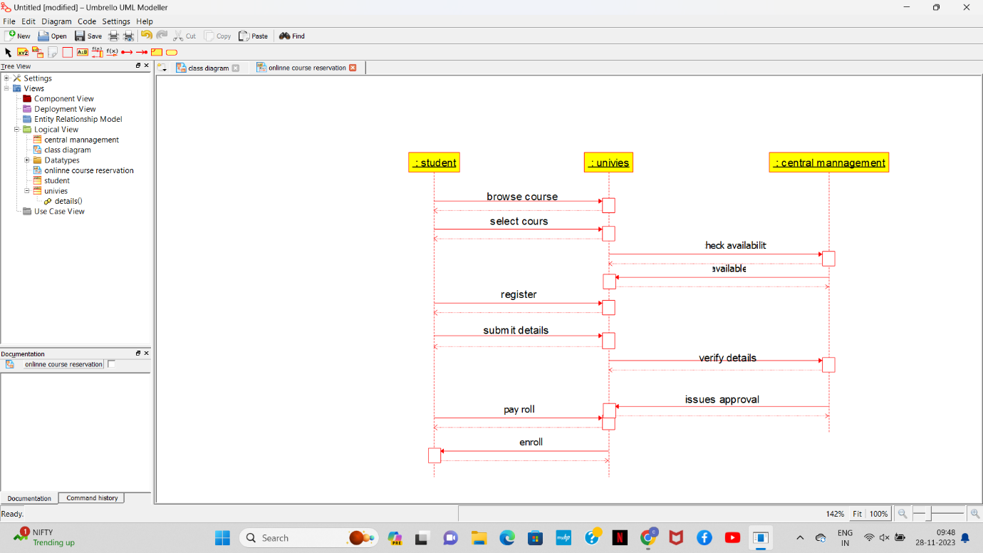

2.HOTEL BOOKING SYSTEM

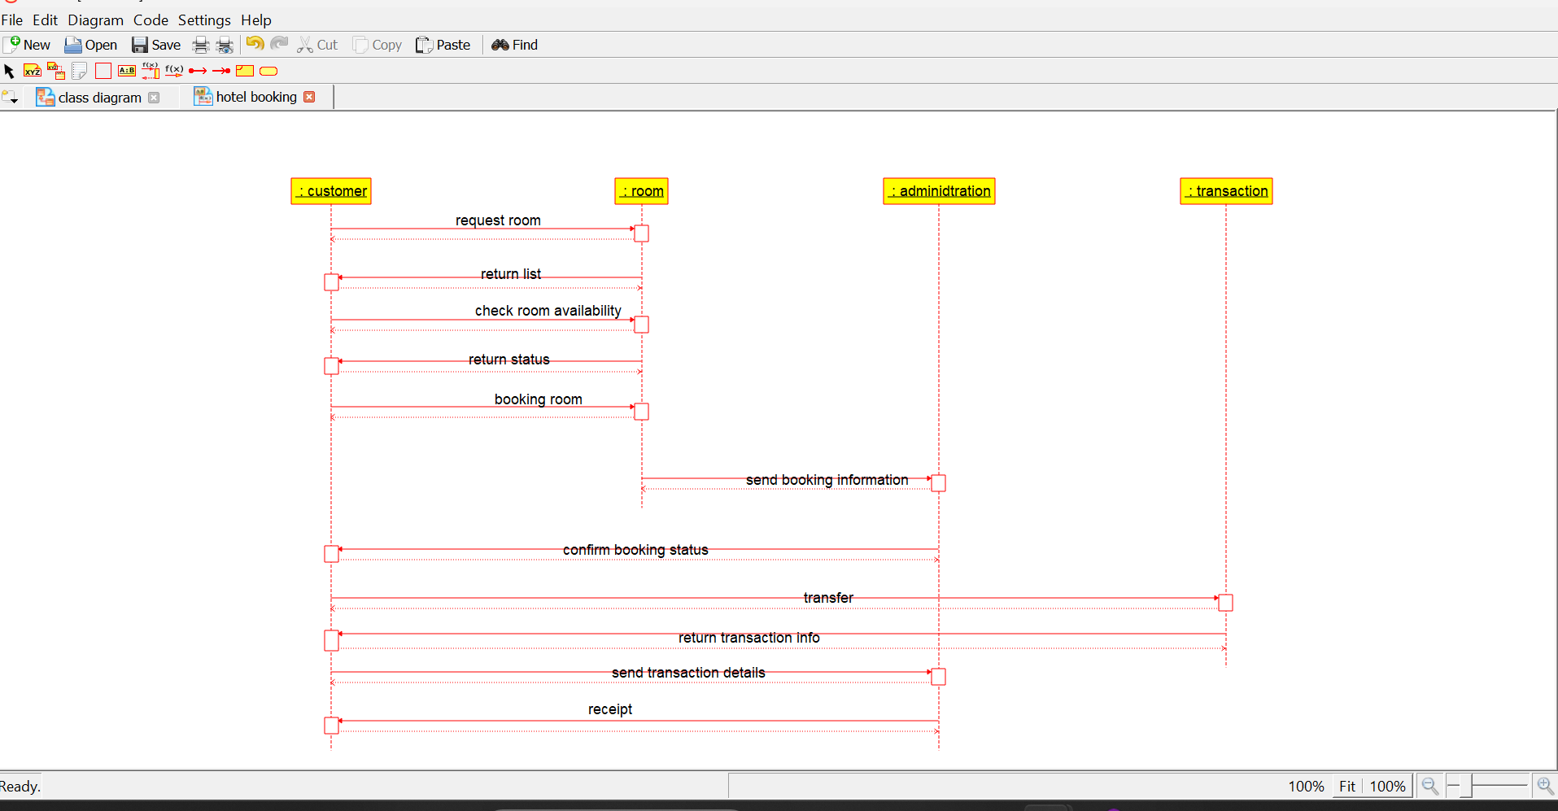

# **STATE DIAGRAM**

# FLIGHT TICKET BOOKING

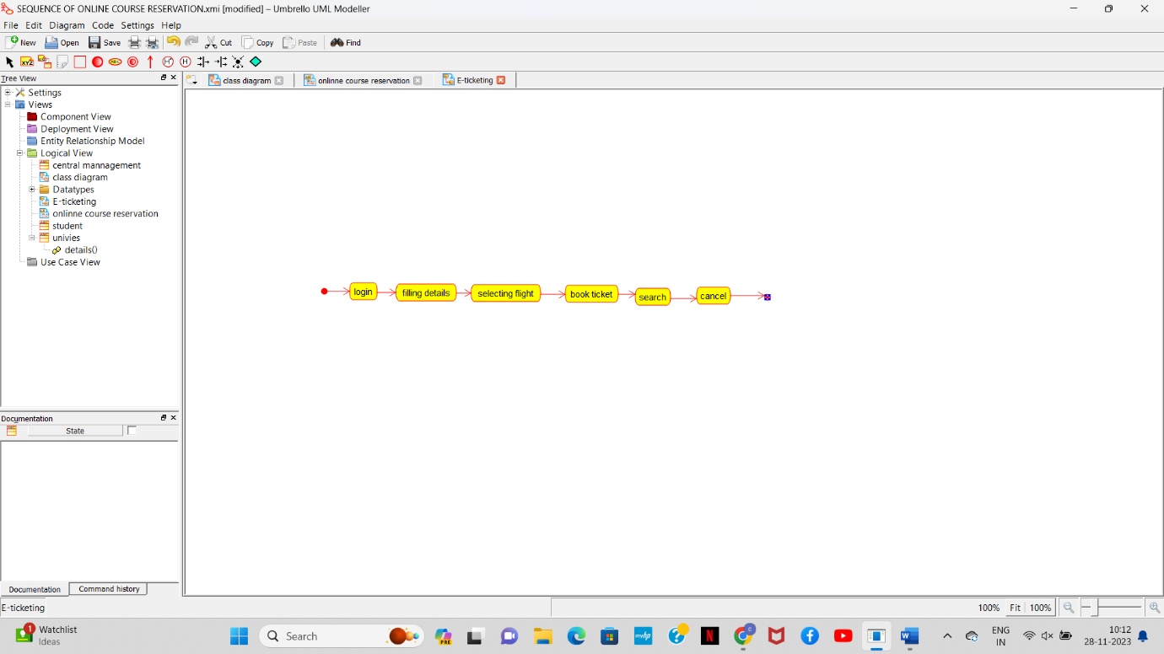

# ONLLINE COURSE RESERVATION

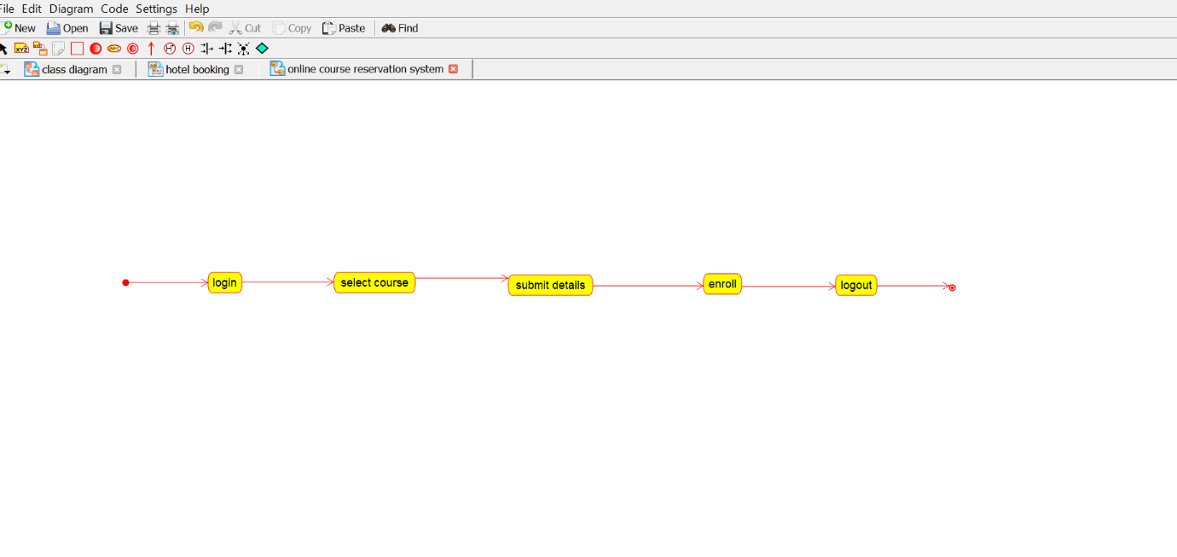

# COCOMO MODEL

#include <stdio.h>

#include <math.h>

// Function to calculate effort using Basic COCOMO model

float calculate_effort(float size, char* mode) {

// COCOMO parameters for different modes

float a, b;

if (strcmp(mode, "organic") == 0) {

a = 2.4;

b = 1.05;

} else if (strcmp(mode, "semi-detached") == 0) {

a = 3.0;

b = 1.12;

} else if (strcmp(mode, "embedded") == 0) {

a = 3.6;

b = 1.20;

} else {

printf("Invalid mode. Choose 'organic', 'semi-detached', or 'embedded'.\n");

return -1;

}

// Calculate effort using Basic COCOMO formula

float effort = a * pow(size, b);

return effort;

}

int main() {

// Example usage

float size_of_project;

char development_mode[20];

printf("Enter the size of the project in KLOC (Kilo Lines of Code): ");

scanf("%f", &size_of_project);

printf("Enter the development mode ('organic', 'semi-detached', or 'embedded'): ");

scanf("%s", development_mode);

float project_effort = calculate_effort(size_of_project, development_mode);

if (project_effort != -1) {

printf("The estimated effort for the project is %.2f person-months.\n", project_effort);

}

return 0;

}

# RAPTOR

1. RAPTOR FOR PRIME:

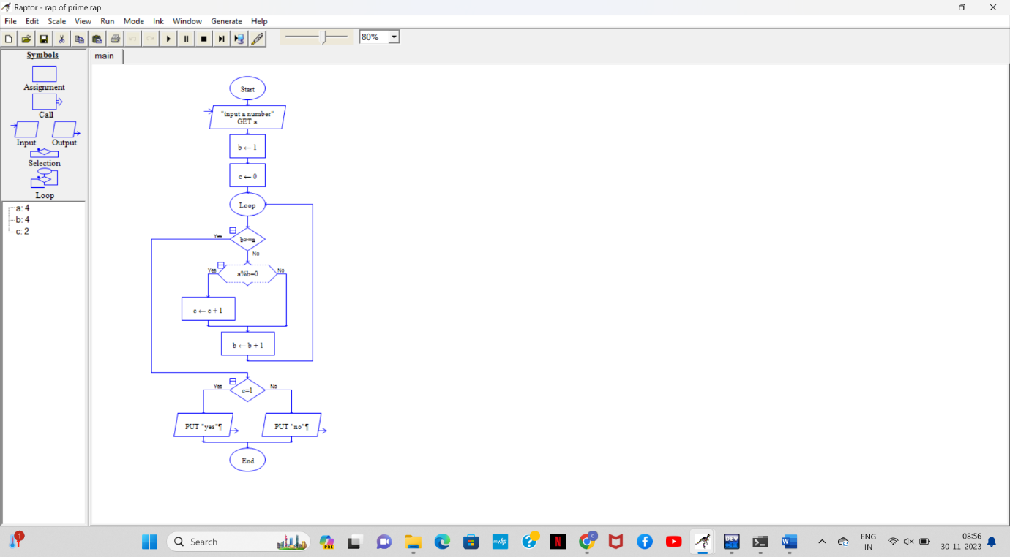

1. RAPTOR FOR SWAP:

